1
Введение

1.1
ПРОИСХОЖДЕНИЕ ИССЛЕДОВАНИЯ ОПЕРАЦИЙ
С момента наступления промышленной революции, мир стал свидетелем значительного роста размера и сложности организаций. Небольшие магазины ремесленников в раннюю эпоху сегодня развились в корпорации, исчисляемые миллиардами долларов.

Since the advent of the industrial revolution, the world has seen a remarkable growth in
the size and complexity of organizations. The artisans’ small shops of an earlier era have
evolved into the billion-dollar corporations of today. An integral part of this revolution-
ary change has been a tremendous increase in the division of labor and segmentation of
management responsibilities in these organizations. The results have been spectacular.
However, along with its blessings, this increasing specialization has created new prob-
lems, problems that are still occurring in many organizations. One problem is a tendency
for the many components of an organization to grow into relatively autonomous empires
with their own goals and value systems, thereby losing sight of how their activities and
objectives mesh with those of the overall organization. What is best for one component
frequently is detrimental to another, so the components may end up working at cross pur-
poses. A related problem is that as the complexity and specialization in an organization
increase, it becomes more and more difficult to allocate the available resources to the var-
ious activities in a way that is most effective for the organization as a whole. These kinds
of problems and the need to find a better way to solve them provided the environment for
the emergence of operations research (commonly referred to as OR).
The roots of OR can be traced back many decades, when early attempts were made
to use a scientific approach in the management of organizations. However, the beginning
of the activity called operations research has generally been attributed to the military ser-
vices early in World War II. Because of the war effort, there was an urgent need to allo-
cate scarce resources to the various military operations and to the activities within each
operation in an effective manner. Therefore, the British and then the U.S. military man-
agement called upon a large number of scientists to apply a scientific approach to deal-
ing with this and other strategic and tactical problems. In effect, they were asked to do
research on (military) operations. These teams of scientists were the first OR teams. By
developing effective methods of using the new tool of radar, these teams were instrumental
in winning the Air Battle of Britain. Through their research on how to better manage con-
voy and antisubmarine operations, they also played a major role in winning the Battle of
the North Atlantic. Similar efforts assisted the Island Campaign in the Pacific.
When the war ended, the success of OR in the war effort spurred interest in apply-
ing OR outside the military as well. As the industrial boom following the war was run-
ning its course, the problems caused by the increasing complexity and specialization in
organizations were again coming to the forefront. It was becoming apparent to a growing
number of people, including business consultants who had served on or with the OR teams
during the war, that these were basically the same problems that had been faced by the
military but in a different context. By the early 1950s, these individuals had introduced
the use of OR to a variety of organizations in business, industry, and government. The
rapid spread of OR soon followed.
At least two other factors that played a key role in the rapid growth of OR during
this period can be identified. One was the substantial progress that was made early in im-
proving the techniques of OR. After the war, many of the scientists who had participated
on OR teams or who had heard about this work were motivated to pursue research rele-
vant to the field; important advancements in the state of the art resulted. A prime exam-
ple is the simplex method for solving linear programming problems, developed by George
Dantzig in 1947. Many of the standard tools of OR, such as linear programming, dynamic
programming, queueing theory, and inventory theory, were relatively well developed be-
fore the end of the 1950s.
A second factor that gave great impetus to the growth of the field was the onslaught
of the computer revolution. A large amount of computation is usually required to deal
most effectively with the complex problems typically considered by OR. Doing this by
hand would often be out of the question. Therefore, the development of electronic digital
computers, with their ability to perform arithmetic calculations thousands or even millions
of times faster than a human being can, was a tremendous boon to OR. A further boost
came in the 1980s with the development of increasingly powerful personal computers ac-
companied by good software packages for doing OR. This brought the use of OR within
the easy reach of much larger numbers of people. Today, literally millions of individuals
have ready access to OR software. Consequently, a whole range of computers from main-
frames to laptops now are being routinely used to solve OR problems.

1.2
СУЩНОСТЬ ИССЛЕДОВАНИЯ ОПЕРАЦИЙ
As its name implies, operations research involves “research on operations.” Thus, opera-
tions research is applied to problems that concern how to conduct and coordinate the op-
erations (i.e., the activities) within an organization. The nature of the organization is es-
sentially immaterial, and, in fact, OR has been applied extensively in such diverse areas
as manufacturing, transportation, construction, telecommunications, financial planning,
health care, the military, and public services, to name just a few. Therefore, the breadth
of application is unusually wide.
The research part of the name means that operations research uses an approach that
resembles the way research is conducted in established scientific fields. To a considerable
extent, the scientific method is used to investigate the problem of concern. (In fact, the
term management science sometimes is used as a synonym for operations research.) In
particular, the process begins by carefully observing and formulating the problem, in-
cluding gathering all relevant data. The next step is to construct a scientific (typically
mathematical) model that attempts to abstract the essence of the real problem. It is then
hypothesized that this model is a sufficiently precise representation of the essential fea-
tures of the situation that the conclusions (solutions) obtained from the model are also
valid for the real problem. Next, suitable experiments are conducted to test this hypothe-
sis, modify it as needed, and eventually verify some form of the hypothesis. (This step is
frequently referred to as model validation.) Thus, in a certain sense, operations research
involves creative scientific research into the fundamental properties of operations. How-
ever, there is more to it than this. Specifically, OR is also concerned with the practical
management of the organization. Therefore, to be successful, OR must also provide pos-
itive, understandable conclusions to the decision maker(s) when they are needed.
Still another characteristic of OR is its broad viewpoint. As implied in the preceding
section, OR adopts an organizational point of view. Thus, it attempts to resolve the con-
flicts of interest among the components of the organization in a way that is best for the
organization as a whole. This does not imply that the study of each problem must give
explicit consideration to all aspects of the organization; rather, the objectives being sought
must be consistent with those of the overall organization.
An additional characteristic is that OR frequently attempts to find a best solution (re-
ferred to as an optimal solution) for the problem under consideration. (We say a best in-
stead of the best solution because there may be multiple solutions tied as best.) Rather
than simply improving the status quo, the goal is to identify a best possible course of ac-
tion. Although it must be interpreted carefully in terms of the practical needs of manage-
ment, this “search for optimality” is an important theme in OR.
All these characteristics lead quite naturally to still another one. It is evident that no
single individual should be expected to be an expert on all the many aspects of OR work
or the problems typically considered; this would require a group of individuals having di-
verse backgrounds and skills. Therefore, when a full-fledged OR study of a new problem
is undertaken, it is usually necessary to use a team approach. Such an OR team typically
needs to include individuals who collectively are highly trained in mathematics, statistics
and probability theory, economics, business administration, computer science, engineering
and the physical sciences, the behavioral sciences, and the special techniques of OR. The
team also needs to have the necessary experience and variety of skills to give appropriate
consideration to the many ramifications of the problem throughout the organization.

1.3
ВЛИЯНИЕ ИССЛЕДОВАНИЯ ОПЕРАЦИЙ
Operations research has had an impressive impact on improving the efficiency of numer-
ous organizations around the world. In the process, OR has made a significant contribu-
tion to increasing the productivity of the economies of various countries. There now are
a few dozen member countries in the International Federation of Operational Research
Societies (IFORS), with each country having a national OR society. Both Europe and Asia
have federations of OR societies to coordinate holding international conferences and pub-
lishing international journals in those continents.
It appears that the impact of OR will continue to grow. For example, according to the
U.S. Bureau of Labor Statistics, OR currently is one of the fastest-growing career areas
for U.S. college graduates.
To give you a better notion of the wide applicability of OR, we list some actual award-
winning applications in Table 1.1. Note the diversity of organizations and applications in
the first two columns. The curious reader can find a complete article describing each ap-
plication in the January–February issue of Interfaces for the year cited in the third col-
umn of the table. The fourth column lists the chapters in this book that describe the kinds
of OR techniques that were used in the application. (Note that many of the applications
combine a variety of techniques.) The last column indicates that these applications typi-
cally resulted in annual savings in the millions (or even tens of millions) of dollars. Fur-
thermore, additional benefits not recorded in the table (e.g., improved service to customers
and better managerial control) sometimes were considered to be even more important than
these financial benefits. (You will have an opportunity to investigate these less tangible
benefits further in Probs. 1.3-1 and 1.3-2.)
Although most routine OR studies provide considerably more modest benefits than
these award-winning applications, the figures in the rightmost column of Table 1.1 do ac-
curately reflect the dramatic impact that large, well-designed OR studies occasionally can
have.
We will briefly describe some of these applications in the next chapter, and then we
present two in greater detail as case studies in Sec. 3.5.
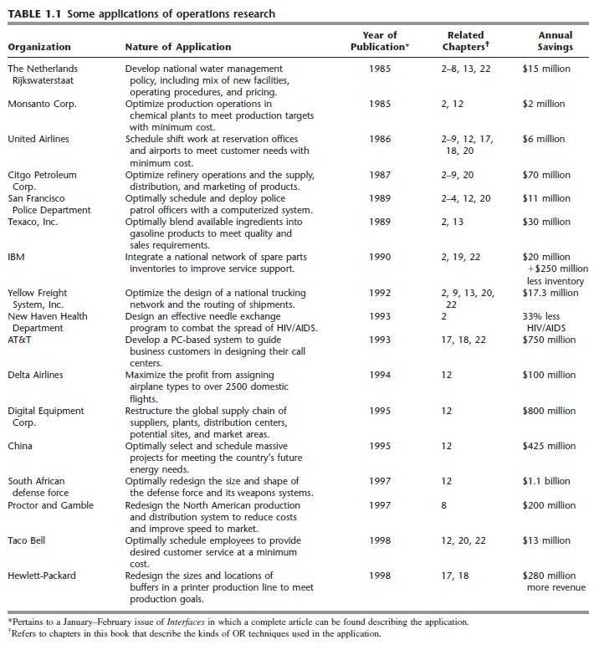
1.4
АЛГОРИТМЫ И ОБУЧАЮЩИЕ ПРОГРАММЫ ИО
An important part of this book is the presentation of the major algorithms (systematic
solution procedures) of OR for solving certain types of problems. Some of these algo-
rithms are amazingly efficient and are routinely used on problems involving hundreds or
thousands of variables. You will be introduced to how these algorithms work and what
makes them so efficient. You then will use these algorithms to solve a variety of problems
on a computer. The CD-ROM called OR Courseware that accompanies the book will be
a key tool for doing all this.
One special feature in your OR Courseware is a program called OR Tutor. This pro-
gram is intended to be your personal tutor to help you learn the algorithms. It consists of
many demonstration examples that display and explain the algorithms in action. These
“demos” supplement the examples in the book.
In addition, your OR Courseware includes many interactive routines for executing
the algorithms interactively in a convenient spreadsheet format. The computer does all the
routine calculations while you focus on learning and executing the logic of the algorithm.
You should find these interactive routines a very efficient and enlightening way of doing
many of your homework problems.
In practice, the algorithms normally are executed by commercial software packages.
We feel that it is important to acquaint students with the nature of these packages that
they will be using after graduation. Therefore, your OR Courseware includes a wealth of
material to introduce you to three particularly popular software packages described be-
low. Together, these packages will enable you to solve nearly all the OR models encoun-
tered in this book very efficiently. We have added our own automatic routines to the OR
Courseware only in a few cases where these packages are not applicable.
A very popular approach now is to use today’s premier spreadsheet package, Mi-
crosoft Excel, to formulate small OR models in a spreadsheet format. The Excel Solver
then is used to solve the models. Your OR Courseware includes a separate Excel file for
nearly every chapter in this book. Each time a chapter presents an example that can be
solved using Excel, the complete spreadsheet formulation and solution is given in that
chapter’s Excel file. For many of the models in the book, an Excel template also is pro-
vided that already includes all the equations necessary to solve the model. Some Excel
add-ins also are included on the CD-ROM.
After many years, LINDO (and its companion modeling language LINGO) contin-
ues to be a dominant OR software package. Student versions of LINDO and LINGO now
can be downloaded free from the Web. As for Excel, each time an example can be solved
with this package, all the details are given in a LINGO/LINDO file for that chapter in
your OR Courseware.
CPLEX is an elite state-of-the-art software package that is widely used for solving
large and challenging OR problems. When dealing with such problems, it is common to
also use a modeling system to efficiently formulate the mathematical model and enter it
into the computer. MPL is a user-friendly modeling system that uses CPLEX as its main
solver. A student version of MPL and CPLEX is available free by downloading it from
the Web. For your convenience, we also have included this student version in your OR
Courseware. Once again, all the examples that can be solved with this package are de-
tailed in MPL/CPLEX files for the corresponding chapters in your OR Courseware.
We will further describe these three software packages and how to use them later (es-
pecially near the end of Chaps. 3 and 4). Appendix 1 also provides documentation for the
OR Courseware, including OR Tutor.
To alert you to relevant material in OR Courseware, the end of each chapter from
Chap. 3 onward has a list entitled Learning Aids for This Chapter in Your OR Course-
ware. As explained at the beginning of the problem section for each of these chapters,
symbols also are placed to the left of each problem number or part where any of this ma-
terial (including demonstration examples and interactive routines) can be helpful.

2
Обзор
Исследования операций
Подход с моделированием
Основная часть этой книги посвящена математическим методам исследования операций (ИО). Это вполне уместно, потому что эти количественные методы составляют основную часть того, что известно об ИО. Тем не менее, это не означает, что практические учения об ИО являются главным образом математическими упражнениями. На самом деле, математический анализ часто представляет только относительно малую часть от общих требуемых усилий. Цель этой главы в том, чтобы представить вещи в лучшей перспективе путем описания всех основных этапов стандартного учения об ИО.
Один из способов суммирования обычных (перекрывающихся) этапов учения об ИО заключается в следующем:
1. Определить интересующую задачу и собрать релевантные данные.
2. Сформулировать математическую модель для представления задачи.
3. Разработать процедуру на основе компьютера для получения решений задачи исходя из модели.
4. Протестировать модель и усовершенствовать ее по мере необходимости.
5. Подготовиться к непрерывному приложению модели как это предписано управлением.
6. Реализовать.
Каждый из этих этапов будет обсуждаться в свою очередь в следующих разделах.
Большинство отмеченных наградами исследований в области ИО, представленных в таблице 1.1., образовывают собой отличные примеры того, как хорошо выполнить эти этапы. Мы будем вставлять фрагменты из этих примеров по всей главе со ссылками для побуждения вашего будущего чтения.

